CCNP Lab 1

The purpose of this lab is to recap what we did in CCNA, and to recreate it in CCNP. I needed to relearn how to set up OSPF on routers and figure out how to do it on the racks. I didn’t really set up OSPF on the racks in CCNA, only in Packet Tracer. I also needed to learn how to set up OSPFv3, which I don’t remember doing at all. Maybe I did some, but it was long enough ago and I did it so little (if any at all) that I pretty much forgot how to do it.

The point of this lab was to enable OSPF for IPv4 and IPv6 across several routers. **O**pen **S**hortest **P**ath **F**irst is a way for routers to talk to each other and say to each other what they are connected to. Normally, routers can only see what they are physically connected too, and nothing else, so they can only see their own networks. This means that trying to connect to a network that isn’t directly connected to the router will fail because the router doesn’t know how to get there. OSPF allows routers to say what networks are attached to them, so all routers within that OSPF area can see each other’s networks, allowing traffic to jump between them.

In summary, I set up 5 routers and enabled OSPF and OSPFv3 on all 5 of them, so that they could all communicate with one another and the PCs on either end of the networks. All these routers are in the same area (0), and they should be able to give each other routes.

Since this lab was mostly a review, I didn’t learn many “new” commands, as I had already set up OSPFv2 (for IPv4) many times in the past. However, I don’t think I've done much, if any, OSPFv3 (for IPv6), but after lots of googling, I know what each necessary command does. The start is straight forward—adding IPv6 addresses (unicast and link local) to the interfaces and enabling IPv6 unicast routing. However, you also need to do an interface configuration command:

ipv6 ospf <process-id> area <area #>

This enables OSPFv3 on the set process ID and area for that interface. The command itself is almost identical to enabling OSPFv2, with the only difference being the “v6” at the beginning of the command. However, when going into router configuration mode, there are two ways, and the “right” way is whichever your router allows. The routers I was using needed the global configuration command:

router ospfv3 <process-id>

But many routers instead use:

ipv6 router ospf <process-id>

However, they are functionally identical, and will both get you into router configuration mode for OSPFv3. The biggest difference between setting up OSPFv2 and v3 is that with OSPFv3, you don’t specify the network that OSPF will be in. You only need a router ID and any necessary passive interfaces, which the commands for that are the same as in OSPFv2. If you have a proper unicast and link local IPv6 address along with the aforementioned interface command, the routers will do the rest.

My network diagram is a Packet Tracer file, and while I can’t send the .pkt file directly, I can send a screenshot of the network diagram. This is what it looks like:

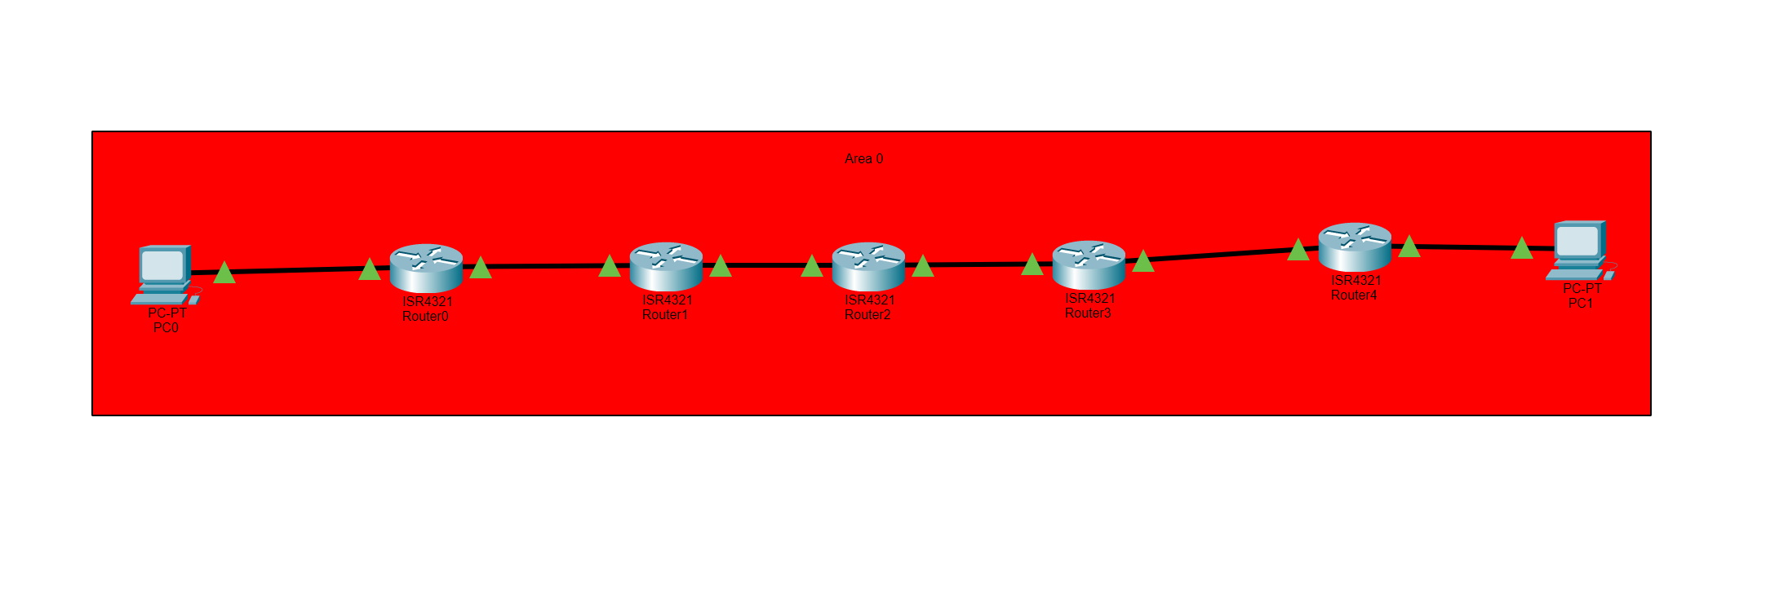

Simply, all routers are on the same area.

My configurations are on 5 separate Word documents, one for each router, and I will send them all when I turn it in for the same reason as the Network Diagram. However, I can show a screenshot of the ping and traceroute from one end device to the other to show that OSPF and OSPFv3 was working properly:

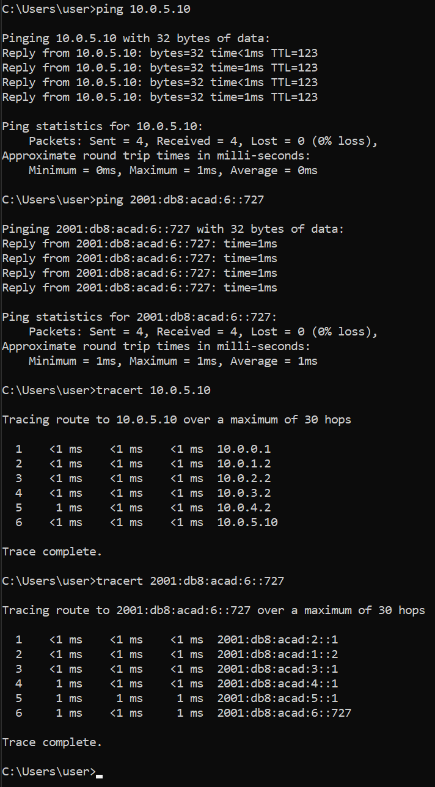

I had several problems setting up OSPF and OSPFv3 on the 5 routers and connecting them to the PCs. For starters, I didn’t at all remember how to set up OSPFv3 (if I ever set it up before in the first place), so I had to look things up quite a bit to learn/relearn how to set it up. Second, while testing if OSPF worked on IPv4, I could ping across all routers and could even ping from a router to a PC. However, I couldn’t ping from a PC to anywhere. This was because I was connected to a Wi-Fi network and turning off my Wi-Fi allowed my PC to ping the routers. Third, I constantly got stopped by the end devices’ firewalls, and had to relearn how to allow exceptions for ICMP and ICMPv6, then I could ping between the end devices. Lastly, and the biggest problem of them all, was the other PC for my rack. For some reason, the PC would not start up at all, no matter which hard drive was in there. The fan was also extremely loud, and the PC was clearly working improperly. Fortunately, the PC started working again, which is why you can see an IP route from all the routers to it. However, I am not sure why it stopped working in the first place, nor do I know how it started working again.

In conclusion, this lab was to set up OSPF and OSPFv3 on 5 routers, and all devices connected should be able to communicate with each other on the network. There were some problems, like not knowing how to set up OSPFv3, having my Wi-Fi on while pinging, and the other PC for the rack not working. I learned how to setup OSPF for IPv6 and remembered that you need to be of the Wi-Fi for ethernet to work on these racks, and overall, I enjoyed this lab quite a bit as it was a good refresher to networking.